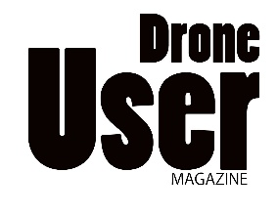 | 7 Starlode Drove, West Pinchbeck, Lincolnshire PE11 3TD

ADVERTISING BOOKING

Company name |  | Contact
Address
Postcode |  | Telephone
Email |  | Website
Industry Sector

I/we would like to place advertising with Drone User Magazine, as detailed below
I/we agree to the terms and conditions of Drone User Magazine

Advertisement Size/format |  | Number of issues
Starting at issue No

Signed by Dated

Terms and conditions
Artwork must reach us on or before the 25th of the publication month – Publication date is the 1st of each month
Payment terms are pre-paid before publication, unless agreed beforehand
Artwork must be 300dpi, preferred jpeg format
Bleed can be right to the edges of the artwork size
Positioning of advertisements cannot be guaranteed unless agreed in advance
Artwork should be emailed to editorial@droneuser.co.uk
It is the responsibility of the advertiser to check accuracy of artwork prior to submission

